Work week rule configuration

Work week rule configuration to define work days, weekends and half days for organization

**Version: 1.0**

**Date: 02-Dec-2020**

*All rights reserved. No part of this publication may be reproduced, transcribed, transmitted, stored in a retrieval system or translated into any language, in any form or by any means mechanical, manual, electronic, magnetic, chemical, optical, including photocopying or otherwise without the prior written permission of UPRAiZAL, Inc.*

Contents

Revision History 4

Requirement 5

Implementation Method 5

Code Modifications 5

**File Path** 5

**Purpose** 5

**Modifications** 5

**File Path** 8

**Purpose** 9

**Modifications** 9

**File Path** 9

**Purpose** 9

**Modifications** 10

**File Path** 10

**Purpose** 10

**Modifications** 10

**File Path** 10

**Purpose** 10

**Modifications** 10

**File Path** 10

**Purpose** 11

**Modifications** 11

**File Path** 11

**Purpose** 11

**Modifications** 11

**File Path** 11

**Purpose** 11

**Modifications** 11

**File Path** 12

**Purpose** 12

**Modifications** 12

**File Path** 12

**Purpose** 12

**Modifications** 12

**File Path** 12

**Purpose** 12

**Modifications** 13

**File Path** 13

**Purpose** 13

**Modifications** 13

**File Path** 14

**Purpose** 14

**Modifications** 14

**File Path** 14

**Purpose** 14

**Modifications** 14

**File Path** 14

**Purpose** 14

**Modifications** 14

**File Path** 14

**Purpose** 14

**Modifications** 15

**File Path** 15

**Purpose** 15

**Modifications** 15

**File Path** 15

**Purpose** 15

**Modifications** 15

**File Path** 16

**Purpose** 16

**Modifications** 16

**File Path** 16

**Purpose** 16

**Modifications** 17

**File Path** 17

**Purpose** 17

**Modifications** 17

**File Path** 17

**Purpose** 17

List of required Jars & File Paths 18

Use cases (Must for Unit Test) 18

# Revision History

|  |  |  |  |
| --- | --- | --- | --- |
| Version | Author | Date | Description |
| 1.0 | HYD0070BI | 19/Jan/2020 | Initial Version |
| 1.0 | HYD0176SD | 22/Jan/2020 | Initial Version |

**Confidentiality**

The contents of this document are considered confidential and proprietary information of UPRAiZAL, Inc. No part of this document may be reproduced, fully or in part, or divulged to any other party without prior written permission from UPRAiZAL, Inc. All logos of respective owner companies used in this presentation are recognized.

# Requirement

Is to give the Admin in the ‘Admin Configuration’ the flexibility to define the working days in the Organization. Based upon this definition the entire UPRAiZAL application should work.

All Tasks Created for Employees should be as per the working days in the week

Employee Utilization Dashboard should also show the Employees Hour utilization only on the working days of the organization.

# Implementation Method

1. Define the number of Days the Organization is working in the whole week
2. Define the Start of Week and End of Week
3. Once the Days off is clear, then define all variations in the week off days
4. Like alternate day working, or half day working etc.

Once the above definitions are made, then the Calendar control in the Application should inherit these rules and show non – working days as non-selectable for the task allocation

# Code Modifications

## **File Path**

"/upraizal-web/src/main/webapp/WEB-INF/tiles/page-header.jsp"

## **Purpose**

* Added code to get work week configuration data once user log in the application.
* Added code to store configuration data in user session object to reuse across the application for date picker data disabling as per configuration
* Added code for date picker data disabling on load of date picker and on change of previous or next months
* If selected month related week configuration data is not present is session object, then calling service to get selected month data and appending the newly requested data to the data object stored in session
* Added code to get display text in configuration page as per week data configuration

## **Modifications**

* code to get work week configuration data once user log in the application and store it in session.

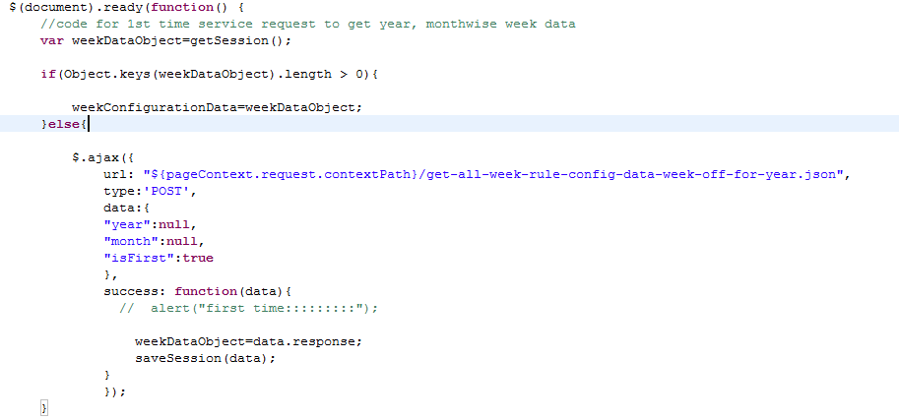.

* Added code for date picker data disabling on load of date picker and on change of previous or next months. To have date picker disabling to work, added **“weekRule”** class name to required data pickers so that single code block of dp.show and dp.update will affect all the required date picker

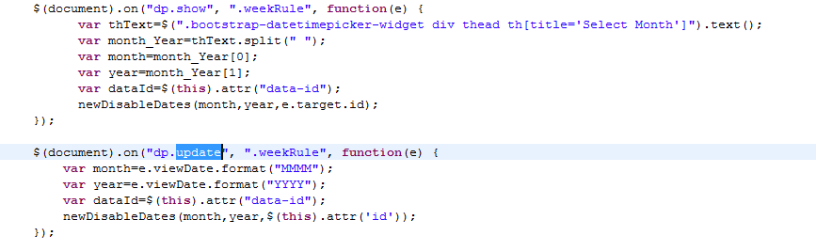

* Code to check requested month related configuration data available or not , in case of absence calling service and appending requested data to session object.

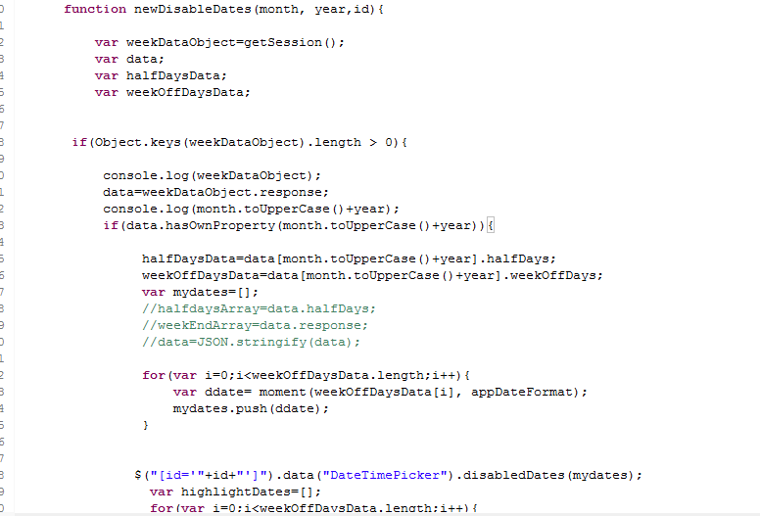

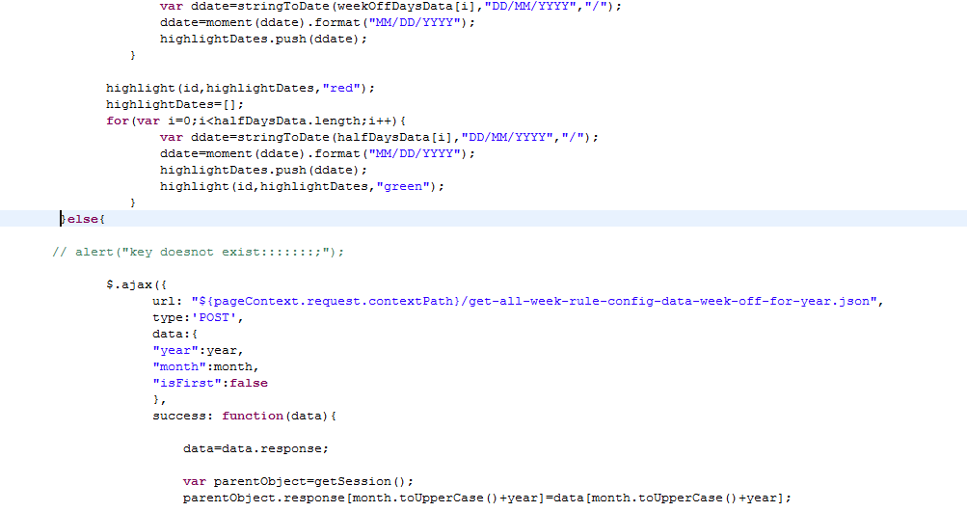

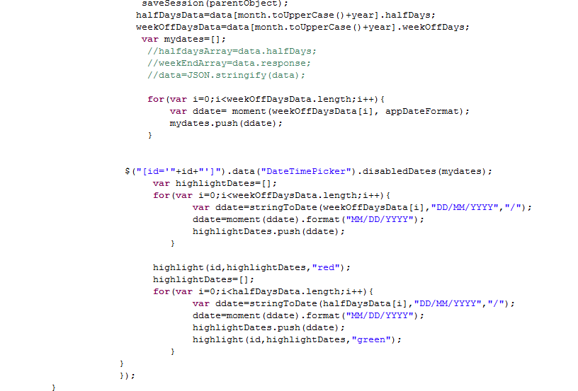

* Added code to get display text in configuration page as per week data configuration.

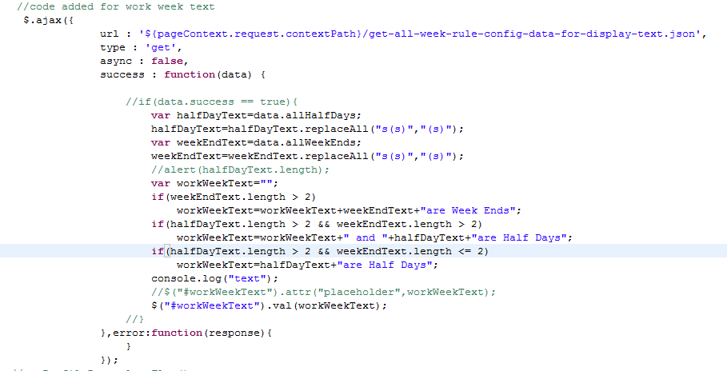

## **File Path**

"/upraizal-web/src/main/webapp/WEB-INF/pages/configuration.jsp"

## **Purpose**

* Code to populate work week table and code for edit and submit of configuration data.

## **Modifications**

* Modified “updateWeekEndsId” click event code for edit and submit functionality of work week table.

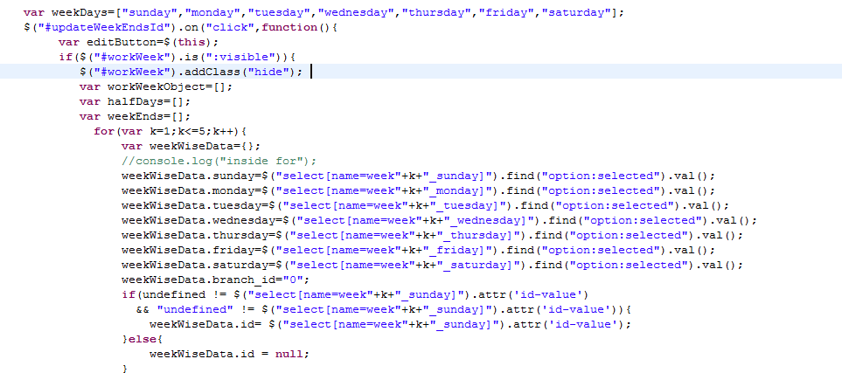

---------------------------------------------------code continuous-----------------------------------------------------------------

## **File Path**

/upraizal-emp/src/main/java/com/defteam/emp/controller/WeekRuleController.java"

## **Purpose**

* Added service call to get the day types to configure week rule data (This is pre-configured lookup data).

## **Modifications**

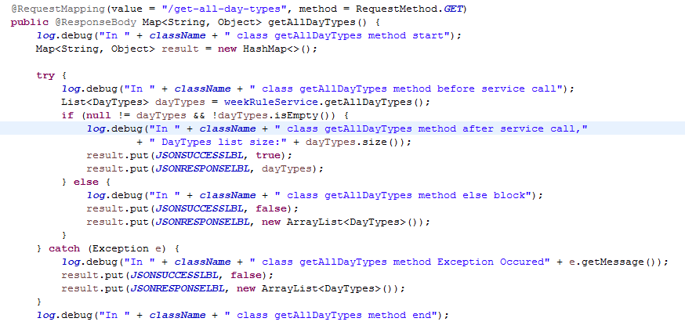

## **File Path**

“/upraizal-emp/src/main/java/com/defteam/emp/service/WeekRuleServiceImpl.java"

## **Purpose**

* Added Service implementation code for fetch the day types data.

## **Modifications**

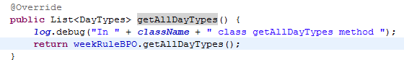

## **File Path**

“/upraizal-emp/src/main/java/com/defteam/emp/service/WeekRuleBPOImpl.java"

## **Purpose**

* Added Busines logic implementation code for fetch the day types data.

## **Modifications**

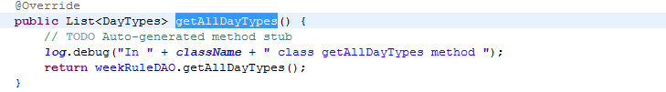

## **File Path**

“/upraizal-emp/src/main/java/com/defteam/emp/service/WeekRuleDAOImpl.java"

## **Purpose**

* Added Data base query implementation code for fetch the day types data.

## **Modifications**

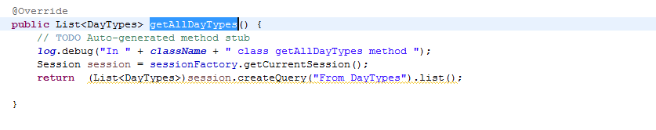

## **File Path**

“/upraizal-emp/src/main/java/com/defteam/emp/controller/WeekRuleController.java"

## **Purpose**

* Added service call to save/update the week rule configure data.

## **Modifications**

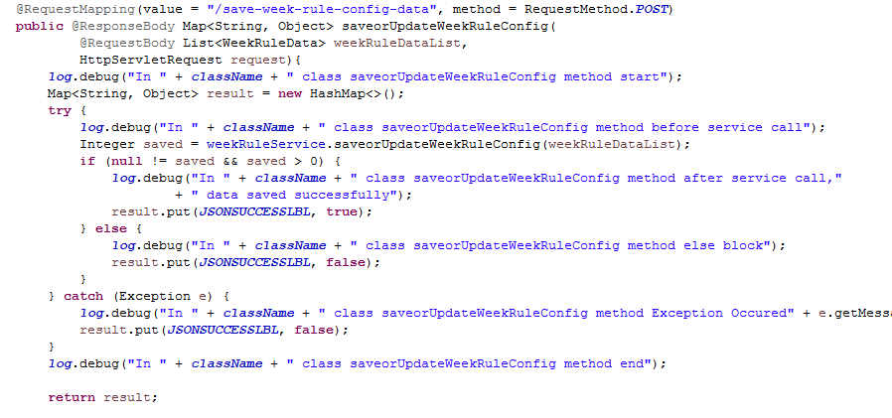

## **File Path**

“/upraizal-emp/src/main/java/com/defteam/emp/service/WeekRuleServiceImpl.java"

## **Purpose**

* Added Service implementation to save/update the week rule configure data.

## **Modifications**

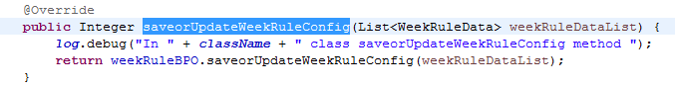

## **File Path**

“/upraizal-emp/src/main/java/com/defteam/emp/service/WeekRuleBPOImpl.java"

## **Purpose**

* Added Busines logic implementation save/update the week rule configure data.

## **Modifications**

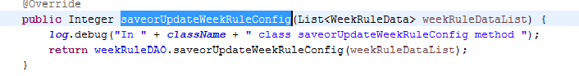

## **File Path**

“/upraizal-emp/src/main/java/com/defteam/emp/service/WeekRuleDAOImpl.java"

## **Purpose**

* Added DB query logic implementation save/update the week rule configure data.

## **Modifications**

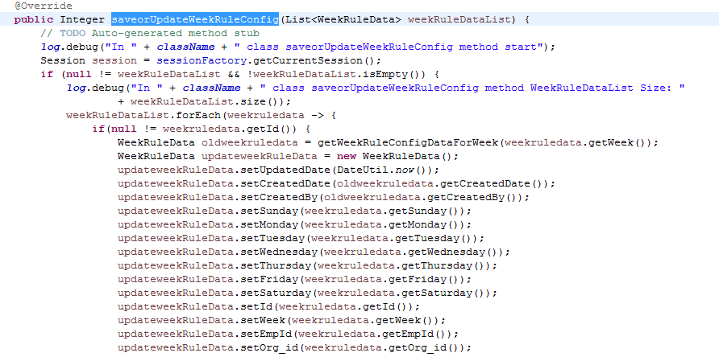

## **File Path**

/upraizal-emp/src/main/java/com/defteam/emp/controller/WeekRuleController.java"

## **Purpose**

* Added service call to get the week rule configure data.

## **Modifications**

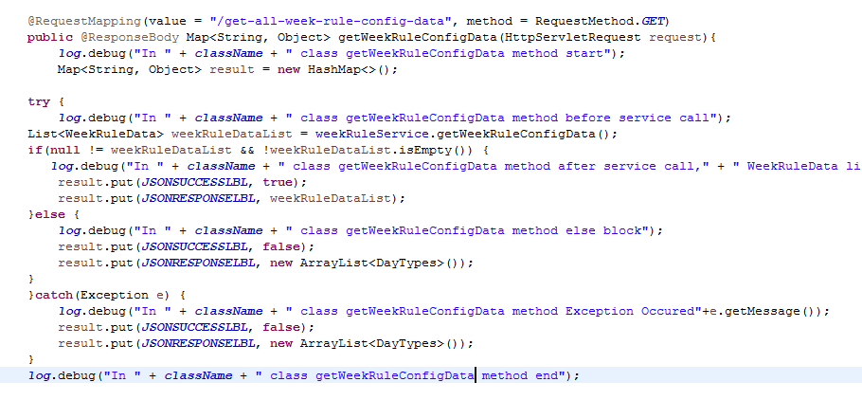

## **File Path**

“/upraizal-emp/src/main/java/com/defteam/emp/service/WeekRuleServiceImpl.java"

## **Purpose**

* Added Service implementation to get the week rule configure data.

## **Modifications**

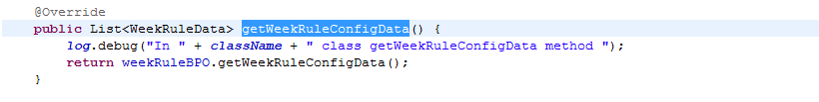

## **File Path**

“/upraizal-emp/src/main/java/com/defteam/emp/service/WeekRuleBPOImpl.java"

## **Purpose**

* Added Busines logic implementation get the week rule configure data.

## **Modifications**

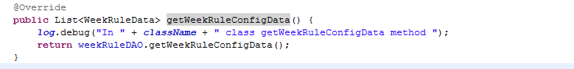

## **File Path**

“/upraizal-emp/src/main/java/com/defteam/emp/service/WeekRuleDAOImpl.java"

## **Purpose**

* Added DB query logic implementation to get the week rule configure data.

## **Modifications**

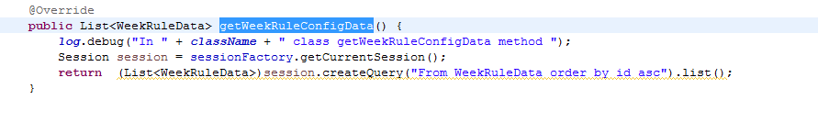

## **File Path**

/upraizal-emp/src/main/java/com/defteam/emp/controller/WeekRuleController.java"

## **Purpose**

* Added service call to get the weekend day’s and half day’s data to disable date pickers.

## **Modifications**

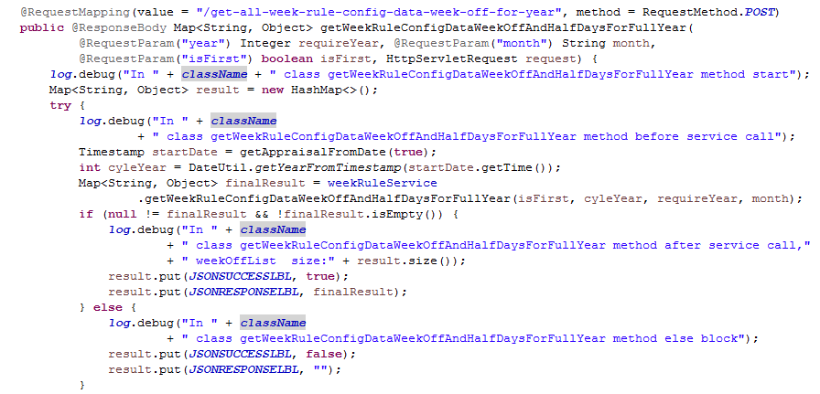

## **File Path**

“/upraizal-emp/src/main/java/com/defteam/emp/service/WeekRuleServiceImpl.java"

## **Purpose**

* Added Service implementation to get the weekend day’s and half day’s data to disable date pickers.

## **Modifications**

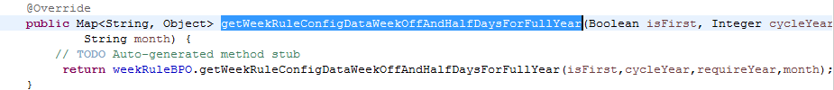

## **File Path**

“/upraizal-emp/src/main/java/com/defteam/emp/service/WeekRuleBPOImpl.java"

## **Purpose**

* Added Busines logic implementation get the weekend day’s and half day’s data to disable date pickers.

## **Modifications**

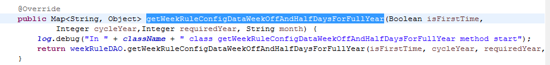

## **File Path**

“/upraizal-emp/src/main/java/com/defteam/emp/service/WeekRuleDAOImpl.java"

## **Purpose**

* Added DB query logic implementation to get the week rule configure data.

## **Modifications**

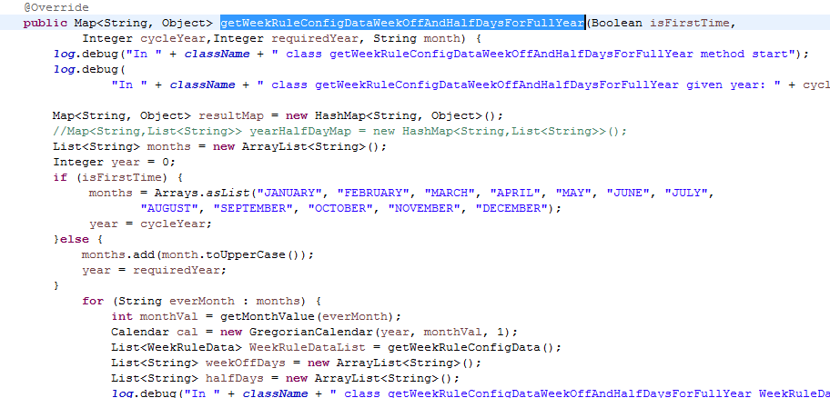

---------------------------------------------------code continuous-----------------------------------------------------------------

## **File Path**

/upraizal-emp/src/main/java/com/defteam/emp/controller/WeekRuleController.java"

## **Purpose**

* Added service call to get the week rule configuration dynamic text to display in the configuration page.

## **Modifications**

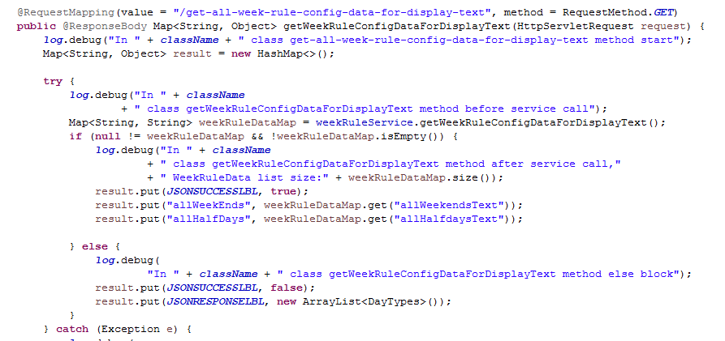

## **File Path**

“/upraizal-emp/src/main/java/com/defteam/emp/service/WeekRuleServiceImpl.java"

## **Purpose**

* Added Service implementation to get the week rule configuration dynamic text to display in the configuration page.

## **Modifications**

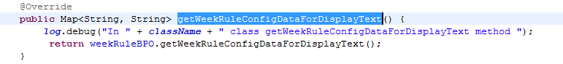

## **File Path**

“/upraizal-emp/src/main/java/com/defteam/emp/service/WeekRuleBPOImpl.java"

## **Purpose**

* Added Busines logic implementation to get the week rule configuration dynamic text to display in the configuration page.

**Modifications**

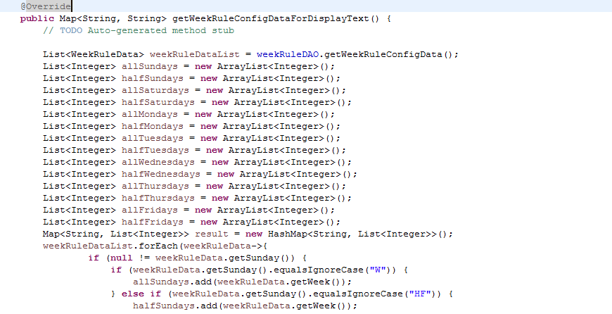

---------------------------------------------------code continuous-----------------------------------------------------------------

# List of required Jars & File Paths

* /upraizal-web/src/main/webapp/WEB-INF/pages/configuration.jsp
* /upraizal-web/src/main/webapp/WEB-INF/tiles/page_header.jsp
* /upraizal-emp/src/main/java/com/defteam/emp/controller/WeekRuleController.java
* /upraizal-emp/src/main/java/com/defteam/emp/service/WeekRuleService.java
* /upraizal-emp/src/main/java/com/defteam/emp/service/ WeekRuleServiceImpl.java
* /upraizal-emp/src/main/java/com/defteam/emp/bpo/ WeekRuleBPO.java
* /upraizal-emp/src/main/java/com/defteam/emp/bpo/ WeekRuleBPOImpl.java
* /upraizal-emp/src/main/java/com/defteam/emp/dao/ WeekRuleDAO.java
* /upraizal-emp/src/main/java/com/defteam/emp/dao/ WeekRuleDAOImpl.java

# Use cases (Must for Unit Test)

1. On first deployment, before work week configuration in general tab, place holder should show “Work week configuration is not done”
2. Once configuration is done, based on configuration text will be displayed on submit
3. As per work week configuration, rules will be inherited by date pickers
4. All weekends will be highlighted in red color and are disabled.
5. All half days are highlighted in green colors
6. Hours calculation should be as per weekends and half days exists in between selected start and end date for task
7. Week rule configuration effects the date pickers in following pages:

Employee page, events, pulse polls, employee utilization dashboard, create, edit and save as draft modals, prepone and hold tasks.